

**EndNote X4**

September 11, 2012

Nancy Schaefer

[nancys@ufl.edu](mailto:nancys@ufl.edu) 352.273.8417

EndNote libraries have two folder extensions: **”.enl”** is the main reference library**; “.Data”** holds the PDFs, documents, images, etc.



Web only



These icons in the upper left indicate which EndNote mode you are using.

You can also change the journal output style in this area.

Library and Web

Journal Style

Library only

1. **Entering References Manually**

Either click **References** in the toolbar and select **New Reference** or click the **green** circle with the white plus sign.



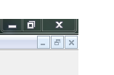

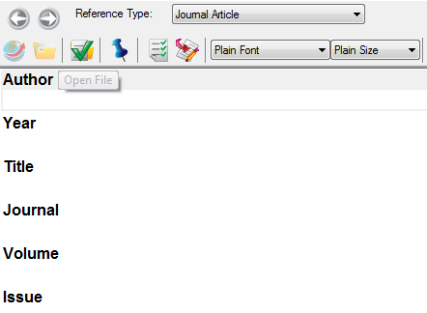

Use the pull down menu of source formats (journal, edited book, etc.) to retrieve the proper form. Then type the information into the form.

Click the **x** in the upper right to save the reference.

1. **Importing references from a file**

**Basic steps:**

Step 1: Perform the search and save the references in a file.

Step 2: Import the references into your EndNote library.

Search MEDLINE using **PubMed.**

Click the citations you want to import.

Click **Send To**,then **Citation Manager.**

The default file name will be 

Give the file a unique, recognizable name and save in the appropriate directory or to the desktop.

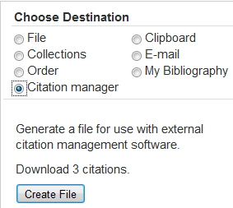



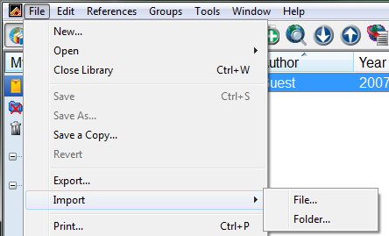

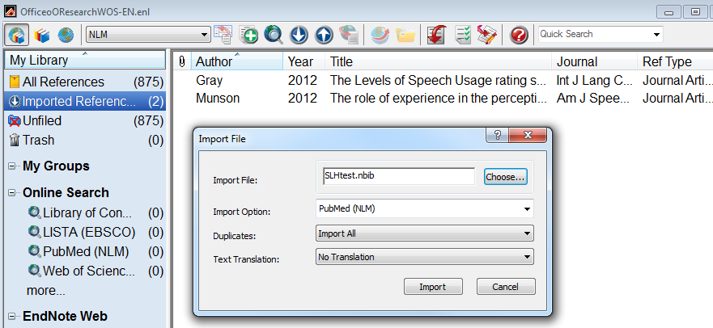You should get a popup window that asks for which file from which database and then, (behind that in the screen capture below), the imported files should appear in your EndNote-- Imported References list.

In your EndNote library, click **File->Import** and select **File.**

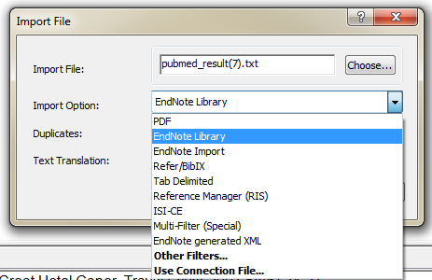 If your PubMed or other files do not import this way, you can try the old method, shown on this page.

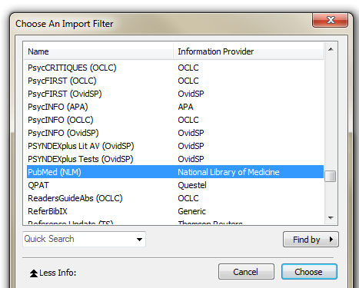

Click **Import. My Library** shows 2 **Imported References** of a total of 3 (the first was input manually. All are still marked as **Unfiled.**

At the **Import File** box, click **Choose** and locate the file containing your citations.

At the pull-down menu labeled **Import Option**, you will need to select **Other Filters** to locate the PubMed/NLM option.

At Import Option select **EndNote Library**, then **Other Filters**.

Scroll through the LONG! list of filters and click on **PubMed (NLM)** (or whatever the appropriate source of the citations). Click **Choose** button beneath the window-list of filters.

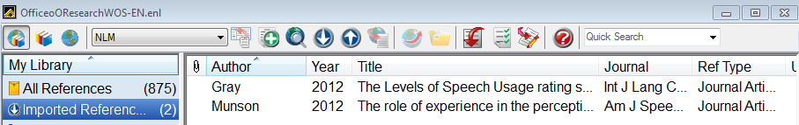Your citations should appear in the Imported References list.

**Import references from a database**

Perform a search in the **Web of Science** database.Mark the citations you’d like and click the **EndNote** button above the results list.

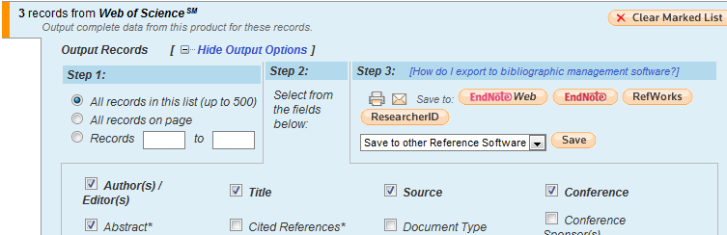

To move all citations you’ve marked from all pages of all searches, click on the number in parentheses above the results list (3) in the previous screen capture, then click the **EndNote** button in the blue box.

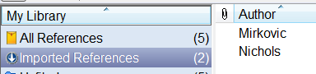

Your references are added to your library. Once the references have been added to your **All References** folder you can delete the **Imported References** group.

1. **Adding References from a library catalog**

From our library’s homepage <http://library.health.ufl.edu> ‘s left sidebar under **Quick Links**, click **Catalog.**

If you know the author or title, use the catalog’s **Advanced Search** pulldowns to specify those terms in those parts of the catalog record so you’ll get fewer results to look through.

Click **Search**.

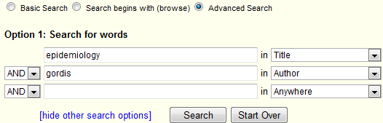



Select the appropriate edition.

Click its **Export icon.**

Select **EndNote.**

Save to desktop or folder.

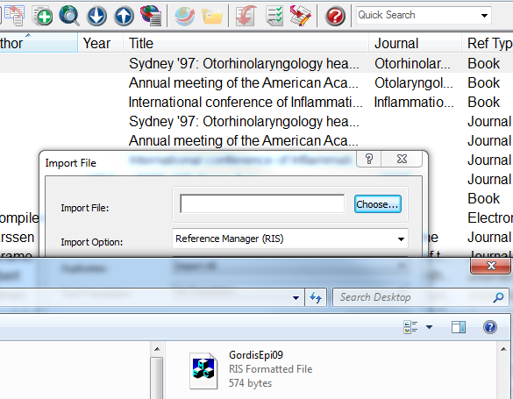Click **Import button** (blue circle with white down arrow) in EndNote’s toolbar.

In the subsequent Import File box, click **Choose**, then select the item from the catalog.The system will recognize it as RIS format.

Click **Import** button.



This also works for books in other state libraries if you follow the catalog results’ **Uborrow** button.



1. **Add PDFs to references**



Download and save the PDF for your reference to the desktop or a folder.



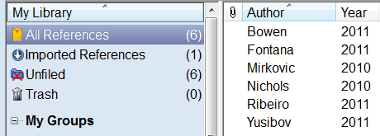

Add the citation for the downloaded/saved PDF to your EndNote library.

Drag the PDF from your desktop and drop it in the reference.

The paper clip icon to the left of the author name indicates the PDF has been attached to the EndNote entry for this item.

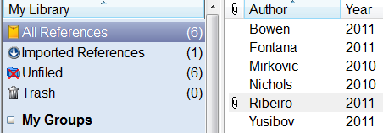OR when you have imported the reference(s), click the **Find Full Text** icon in the toolbar.



Find Full Text…

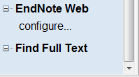

OR click **Find Full Text** at the bottom of the left sidebar.

Note: EndNote X5 supposedly automatically imports PDFs as they are available to you.

1. **Working with Documents**



Open your document in **Word** and click on the **EndNote tab** to open the toolbar.Use the **(output) Style** pulldown menu to change to the journal/bibliographic style needed.

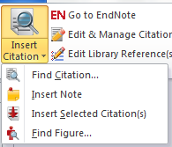

Place your cursor in the Word document where your in-text citation should appear**.**

Click **Insert Citation** and drag to **Find Citation**.

Enter a keyword in the subsequent search box to locate the reference you need.

Select that reference and click **Insert.**

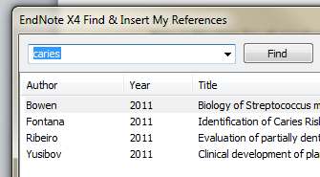





The reference is placed at the end of the document and the appropriate notation appears in the text.



You can also select a reference in your library and click the **Insert Citation** button.

1. **Working with Groups**

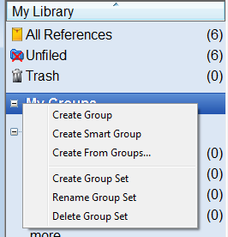

Select the references to add to the group from the library. You may be able to just drag them into the new group. Otherwise, click **Groups** in the toolbar, then **Add References To** and select your named group.

Right click on **My Groups** and select **Create Group.**

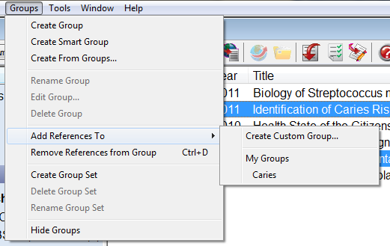

The references will be added to the named Group. In this example, notice that 4 of the 6 references are still unfiled.

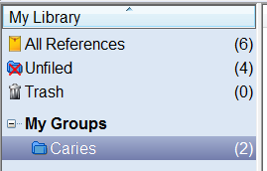

**Smart Groups** search your library for new references that match a saved search strategy. It’s a way to build a subset of your library for a given subject.

