ENC3254 Spring 2014

|  |  |  |
| --- | --- | --- |
| **Database** | **Provider** | **“Best for” Subjects** |
| Academic Search Premier | EbscoHost | Multidisciplinary |
| CINAHL | EbscoHost | Rehabilitation, non-pharma/surgical/medical treatment |
| Communication & Mass Media Complete | EbscoHost | Possibly the best source for non-verbal communication |
| ERIC | ProQuest | Language skills learning, school-based practice, deaf ed, training (including of parents and therapists) |
| Linguistics and Language Behavior Abstracts | ProQuest | Phonation, articulation, syntax, vocabulary, semantics, |
| PsycINFO | EbscoHost | Psychology, psychosocial aspects of diseases, memory |
| PubMed | PubMed | Anatomy, physiology, medical-surgical-pharmaceutical treatment, medical devices, overall health/QOL issues |
| Web of Science | Web of Science | 3 editions (default searches all three): Science, social science and arts & humanities. IDs articles used to build a good article *and* articles that cited it after its publication. |

**Basic Searching Techniques**

**Truncation** *

stutter*= retrieves stutter, stutters, stuttering, stuttered, stutterer, stutterer’s, stutterers, stutterers’

**Phrase searching** “ two or more words adjacent in order given” including words like THE, WITH, OF that are usually not searched and Boolean operators (AND, OR, NOT) when they are used as search terms rather than as commands

“newborn hearing screening” “hearing in noise”

NOTE: Some databases allow truncation within phrase searching; others (like PubMed) do not.

**AND OR NOT**

AND requires ***both*** *terms* to be present in all retrieved items. Generally used with *different concepts*:

loudness AND measurement

OR allows ***either*** term to be present. Generally used with *synonyms (different words for same concept*):

measurement OR assessment

NOT deletes citations that include the 2nd term from the set of those that include the 1st term

swallow NOT bird

If you have only one search box and are using two or more DIFFERENT combining words, use parentheses to indicate how you want to combine the terms:

swallow* NOT (bird OR avian OR aviary)

(dysphagia OR deglutition OR swallow*) AND (therapy OR therapies OR treatment*)

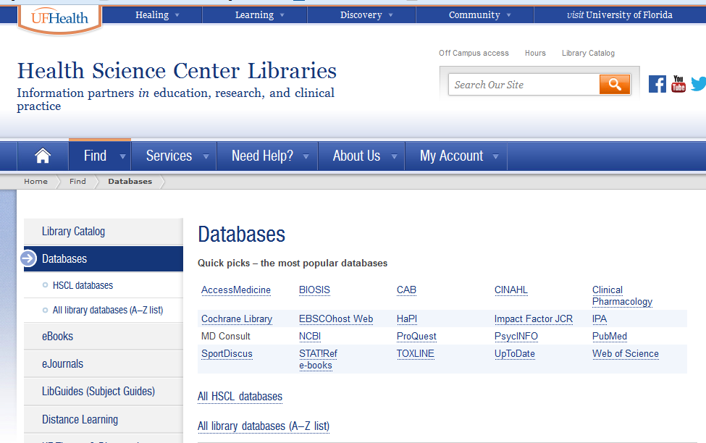

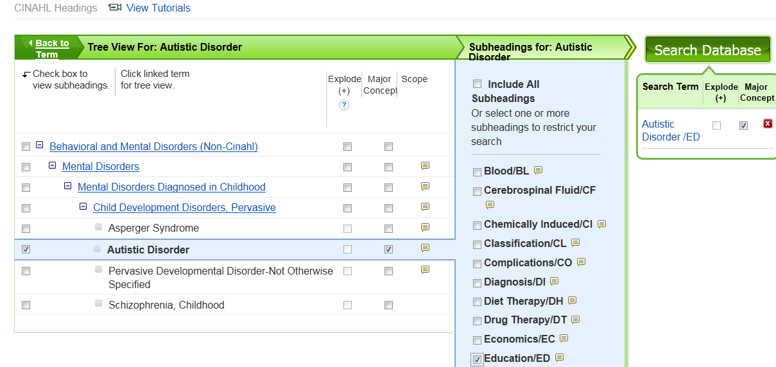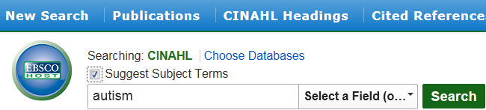







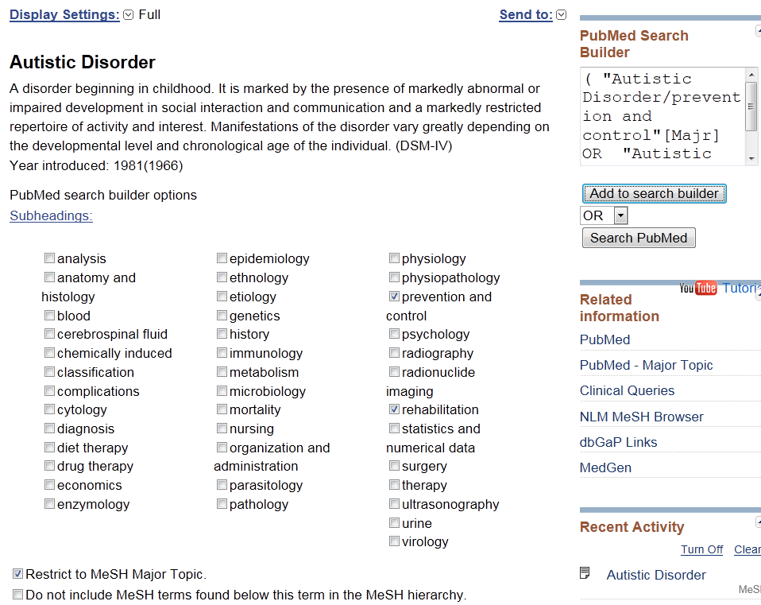

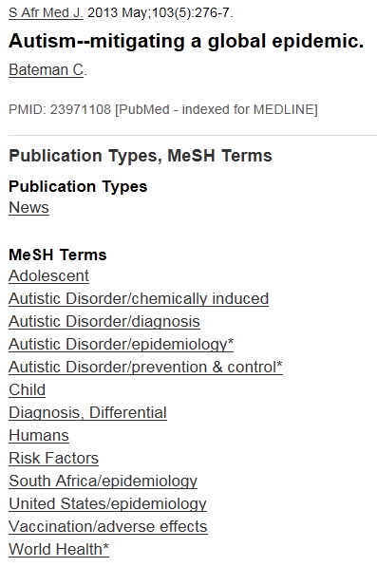

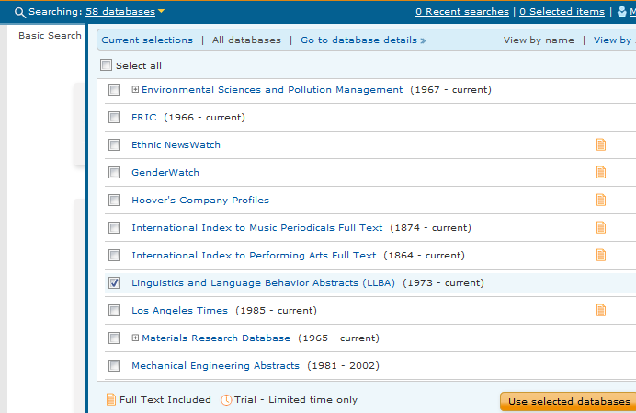PROQUEST

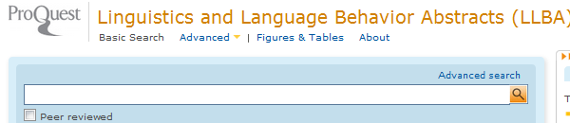

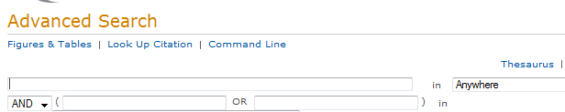





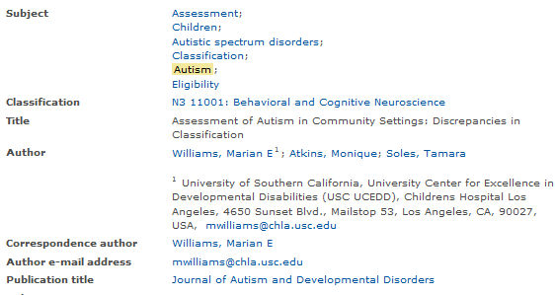

For full-text thru UF: 

**Subject Headings**

Database employees read an article, then attach set phrases called subject headings to summarize its contents to the database record for the article. PubMed’s subject headings are called **Medical Subject Headings**, commonly shortened to MeSH.

If you type in a term from just out of your head (called “keyword searching”) and that term is also a subject term, PubMed automatically includes the subject heading in the search.

In the examples below, I’d typed in just vertigo in the first example and “cochlear implants” in the second, but PubMed searched as follows:

EXAMPLE 1: "vertigo"**[MeSH Terms] OR** "vertigo"**[All Fields]**

EXAMPLE 2: "cochlear implants"**[MeSH Terms]** OR ("cochlear"**[All Fields]** **AND** "implants"**[All Fields]**) **OR** "cochlear implants"**[All Fields]**

*Why take the time to search specifically with subject headings?*

1. You can read how the database **defines** the term, so you can be more certain that it’s searching for the same idea that you have in mind.
2. **Subheadings** – These narrow the results to just one or more specific aspects of the topic.

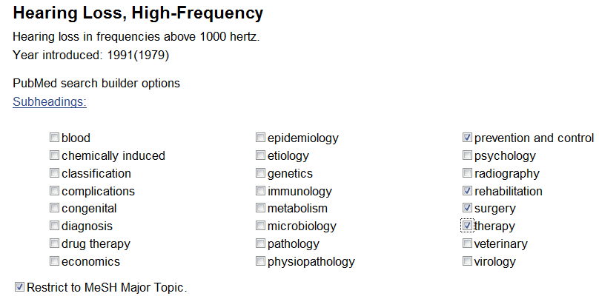PubMed and EbscoHost databases (like CINAHL and Communication and Mass Media Complete) allow you to search on one or more subheadings, as shown below. Use **OR** to search multiple subheadings simultaneously.

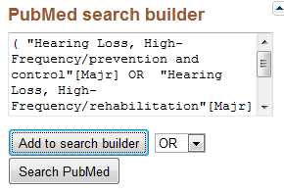

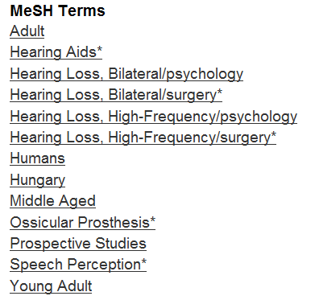**MAJOR** Database employees also specify which ideas are the central or major focus of the article. These are marked with * in the list of subject terms that summarize the subject content of an article.

Scanning the list of subject headings attached to a particular article quickly gives you a sense of what the article is about. It is really the only way to evaluate the usefulness of the relatively few citations in PubMed without abstracts.

At left: One citation’s list of subject headings (MeSH terms) with their subheadings (after the forward slash /-- see examples at Hearing Loss) and *Major* Topics (marked with *)

Possible subject heading search strategies:

"Hearing Loss, High-Frequency"[**MeSH**] (**includes *both*** **MeSH and Major**\*MeSH)

"Hearing Loss, High-Frequency"[**Majr**] (includes ***only* Major\*** MeSH)



Databases use different terms to indicate subject headings and subject heading lists:

PubMed uses MeSH terms in its MeSH Database

CINAHL uses CINAHL Headings, which include some MeSH terms, like for anatomy, health administration, etc.) You can require these to be Major and include subheadings, like this example of Autistic Disorder/rehabilition as a Major focus of the article 

EBSCO’s PsycINFO and Communication & Mass Media Complete databases use Descriptors (abbreviated DE), which are stored in the area called Thesaurus 

A database’s subject heading area displays subject headings arranged hierarchically, from broadest/most general term along the left margin to narrowest/most specific (most indented) terms. These “trees” of terms can help you find subject headings that are more general or more specific than the word you originally looked up so you can increase or decrease (respectively the number of results you get from a search.

Using the example below, if you get too *few* results searching on **Hearing Loss**, you could move UP the “tree” of terms, trying the next broader-level term (**Hearing Disorders**) or one of the even more general terms (**Ear Diseases** or **Otorhinolaryngologic Diseases**).

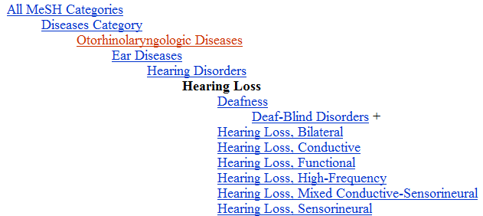On the other hand, if you get too *many* results on **Hearing Loss**, you could move DOWN the “tree” of terms to a more specific term: for example, to **Deafness** or **Hearing Loss, High-Frequency**:

Original term

**More General**

**More Specific**

To search on specific aspects (subheadings) of a topic (subject heading):

1. Click on the appropriate checkbox in front of the subheadings you want to include in your search
2. In the right sidebar, click **Add to search builder**.
3. 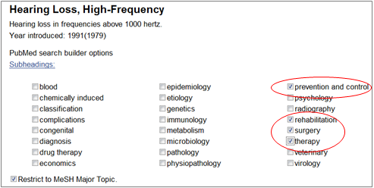If adding two or more subheadings, adjust the pull-down from default AND to OR) then click **Search PubMed**.

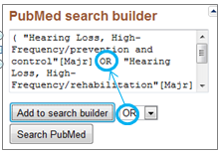

**The Value of Subheadings:** Subheadings attach *directly* to the subject heading so you only get results that are on, for example rehabilitation *of* hearing loss. If you search rehabilitation *and* hearing loss separately, you’ll retrieve every record that contains the word **rehabilitation** (for any condition) that also happens to contain the phrase **hearing loss.**

**BOTTOM LINE:** The pre-searching work of finding subject headings and subheadings pays off with less “garbage” to read thru AFTER searching.

**[Article title in square brackets** = Full-text (tho not abstract) in **language that is not English]**

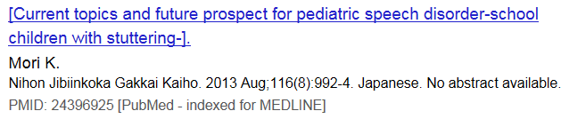To see which language, look toward the end of the line under the author name.

All *abstracts & article titles* are in English, but PubMed is a very international database and links to full-text in dozens of languages.

**Selecting Results**

Click in the checkboxesof desired articles.

In PubMed, click **Send to** at the right just above the results list and click the appropriate radio button.

**Saving Search Results**

Select results of interest and store TEMPORARILY for later output. This storage space is called different things in different databases but is usually in upper right section of the results pages:

PubMed = Clipboard (top right) ProQuest = Selected Item (top right)

Ebsco databases = Folder (top right) Web of Science = Marked List (center, above results)

**Permanent storage** is called **Collections** in PubMed, **Save/Alert** for storing both results and search strategy in other databases.

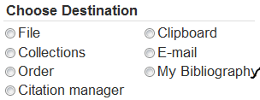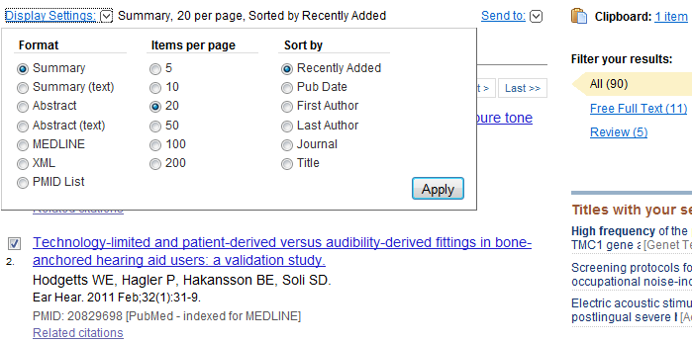



**Database vs. Catalog**

*Databases* list what has been *published*.

The library’s *catalog* lists what the library has *purchased or licensed* for UF users.

The two types of tools are linked so you can search a database to find what’s been published (database) and use its link to the catalog to see if the UF libraries have access.

**Catalog**

From the library’s homepage <http://www.library.health.ufl.edu/> , click **Catalog** under **Quick Links** in the bottom left corner. The catalog tells you what ALL libraries in the UF library system have. **READ CAREFULLY** at **Location** (just under format icon) to see which library holds the source you want.

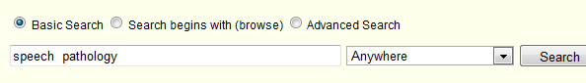Use the pull-down menu to specify where your terms should appear – in the title (of books, videos, computer files), journal titles (only), author name, etc.



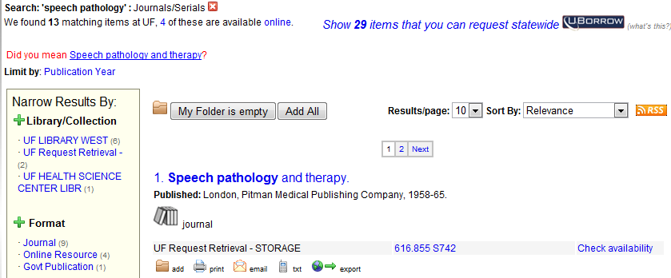On the left at the top of the results page, you’ll see the total # of results. Clicking on the hyperlinked word online in the example below will limit to just the 4 online resources.

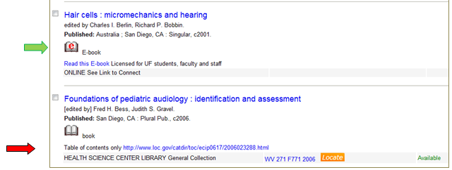Electronic resources will have a red **e** on them, like the Ebook vs. the print book shown below. With print books, record the call # (boxed at left) so you’ll be able to find the item on the shelf.

Select to folder or output individual items.

Call #s. Ends of library bookshelves usually indicate range of call #s on the shelves

Which library holds the print

**Online help:**

Audiology LibGuide <http://guides.uflib.ufl.edu/Audiology>

Speech-Language Pathology LibGuide <http://guides.uflib.ufl.edu/speech-language>

#### Writing/Publishing LibGuide <http://guides.uflib.ufl.edu/write_publish>



Guide: job ad sources, resume/cover letter/personal statement writing, grad school tips for SLP/audiology: <http://guides.uflib.ufl.edu/ENC3254CSD_prof_writing>

Questions? I’m here to help!

Phone: 352.273.8417

Email: [nancys@ufl.edu](mailto:nancys@ufl.edu)

Immediate help 10am-3pm weekdays: Health Science Center Library Info desk 352.273.8408.

Sunday pm->Friday am: reference email <http://library.health.ufl.edu/forms/reference.html>

Questions? I’m here to help!

Phone: 352.273.8417

Email: [nancys@ufl.edu](mailto:nancys@ufl.edu)