**Web of Science**

Go to <http://www.library.health.ufl.edu/>

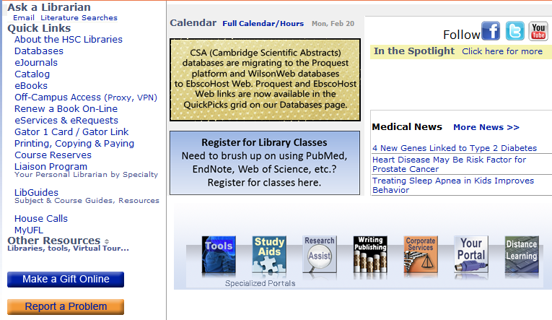From off-campus OR a computer with a non-UF IP address:

**START** with **Off-Campus Access** should be your first step in accessing electronic databases, journals and books.

Click **Report a Problem** to let us know if you can’t get access to a journal/book/ database online that our catalog/databases page says we have access to.

**VPN** (Virtual Private Network) = software you download on 1 non-shared computer that assigns that computer you’re on an IP address within UF’s valid range.

**EZProxy** connects you without downloading software. Can use on shared computer. Need to login each time; will be popped out without notice if you use your browser’s Back button to navigate rather than links on the page/screen and that means you’ll need to log in again.

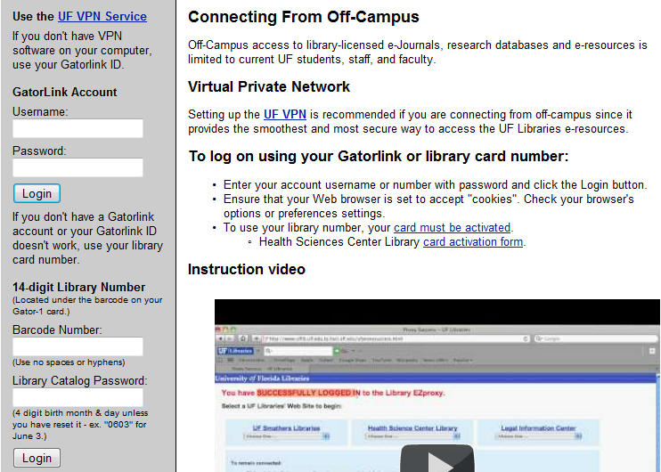

Click **Launch EZ Reconnect** to log

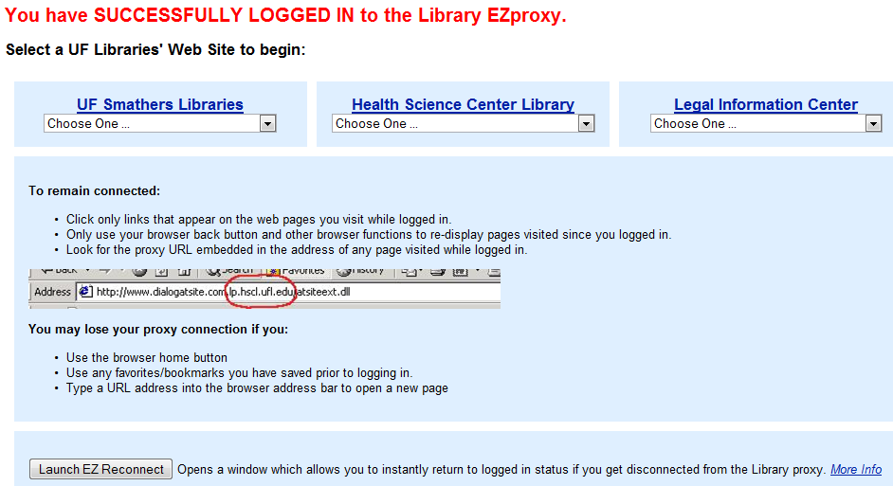

**Basic Searching Review**

**Truncation** *

disab* = retrieves disable, disables, disabled, disabling, disability, disabilities

**Phrase searching** “ two or words adjacent in order given”

“cerebral infarction” “hearing in noise”

NOTE: Some databases allow truncation within phrase searching; others (PubMed) do not. PubMed’s automatic “term suggestion” feature does NOT put quotation marks around 2+ word suggestions but Web of Science does. Note: most bibliographic databases will not search on function words (prepositions, conjunctions) but you can often force them to by including the function word with surrounding nouns in quotes, as in the phrases “hearing in noise” or “dilatation and curettage”.

**BOOLEAN OPERATORS (AND OR NOT)**

AND requires *both terms* to be present in all retrieved items. Generally used with *different concepts*:

deafness AND elderly

OR allows *either* term to be present. Generally used with *synonyms*:

audiology OR hearing science

NOT excludes citations with the word after NOT

hearing NOT congressional

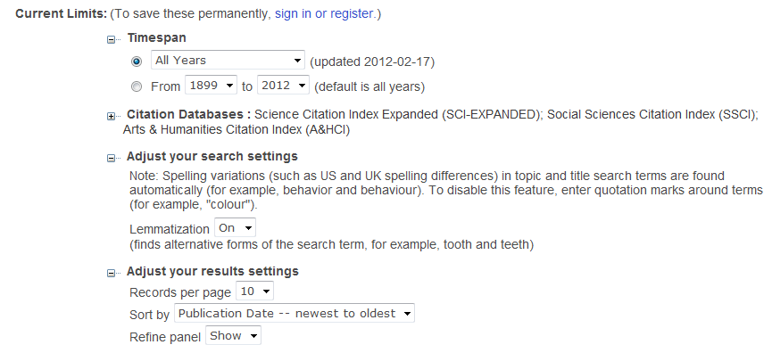**Lemmatization** – Web of Science offers this alternative to truncating to capture plurals and British spellings

**Navigating to** the database:

At the library’s homepage <http://www.library.health.ufl.edu/> click **Databases** under **Quick Links**

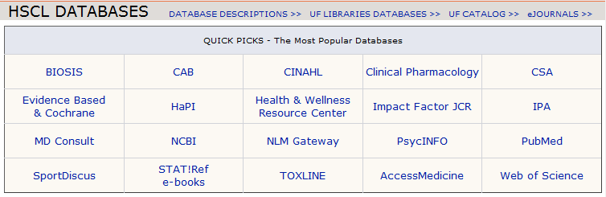On the Databases page, click the bottom right cell of the Quick Pick grid: Web of Science

One way to search is to put all your search terms in a **single search box**.



Use **parentheses ( )** to indicate clusters w**hen using different combining words (AND, OR, NOT),** much as you do in a math statement like (2 x 3) – 1.

Web of Science gives you 3 search boxes and the ability to change where you want the system to search for the terms in each. In the 1st search below, the pull-downs have been changed from their default so that the system is looking for the words in each of the three boxes the same way. The pull-downs on the left should always be the SAME word (AND, AND or OR, OR)

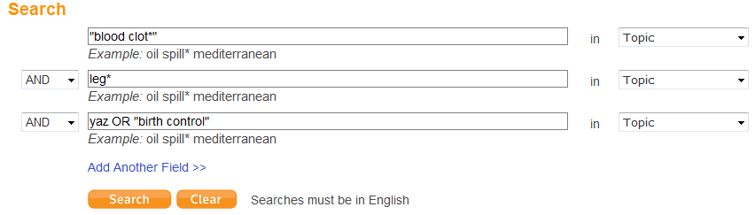

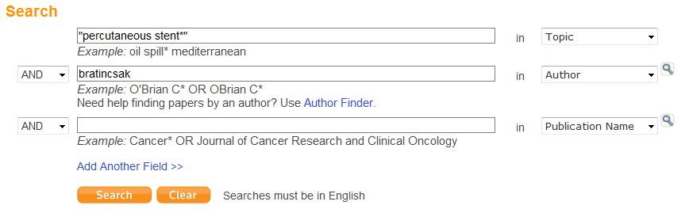This second search is for an item for which you have information on the author and “publication name” (journal title).

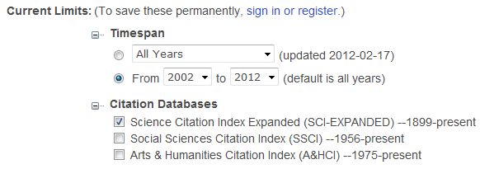You can set limits before you run the search under these boxes.

Below is s a sample search strategy. Hyphenated words should be searched both with and without the hyphen. Each search box can contain as many synonyms/related terms to one concept as you can think of, connected with OR in capital letters. In the top box we want some version of overmedicate/overmedicated/overmedication and also overdose but only as it applies to medicine—not to recreational or street drugs.

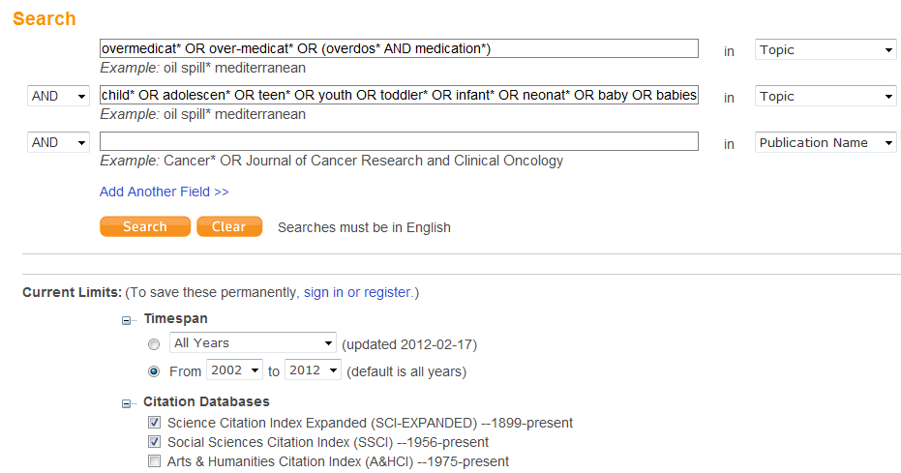

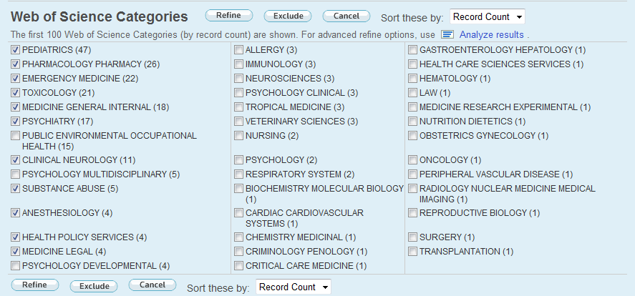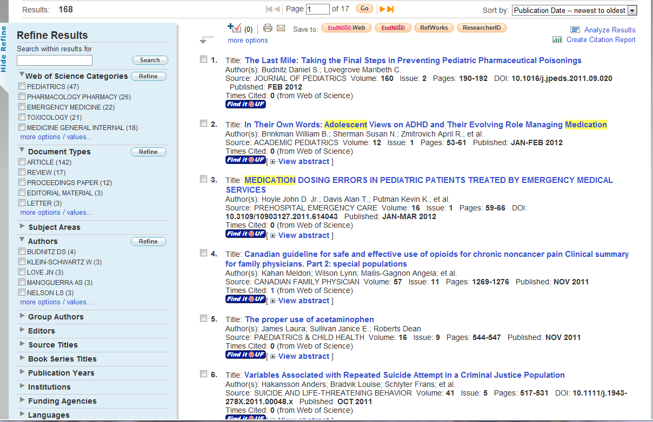Limit after the search using the arrows and checkboxes and more options/values links in the left sidebar.

Click **View Abstract** to show a summary of the article while still on the results list. Click Hide to close the summary window.

Search terms highlighted in yellow.

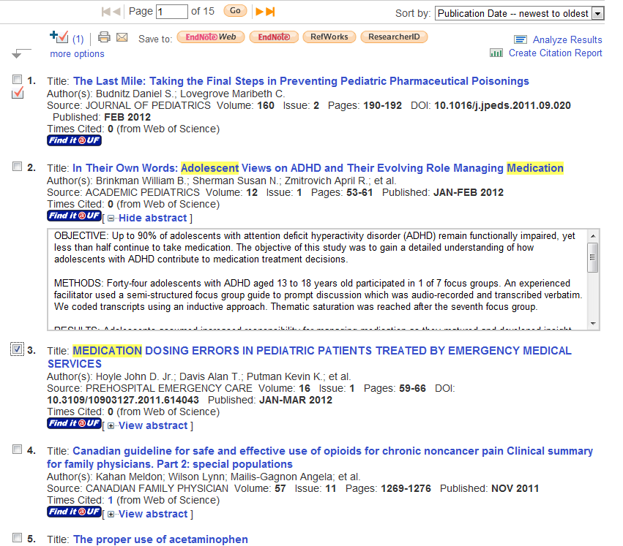Click checkbox of an interesting article, then the + sign above the list to add it to a storage area for later email/export/printing.

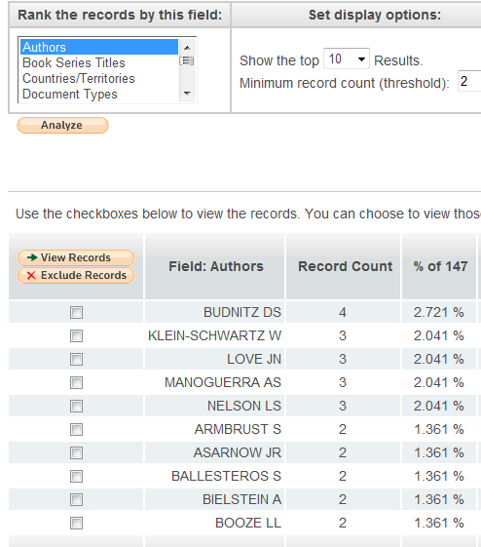

Times Cited indicates number of articles *indexed in this database* that cite this article in subsequent publication. Click this hyperlinked # for citation info on those subsequent publications.

Click **Analyze Results** above results or at bottom of Refine Results (left of page area shown above) to run statistics on aspects of the results, as shown at right. Other useful criteria (not shown): funding agencies, Institutions, Publication years, Source (journal) titles.

Click article title hyperlink in results list for full record, including (sometimes) complete author names (full first name), link to list of references used in the article (Cited References), author affiliations, reprint author contact info, and keywords provided by the author.

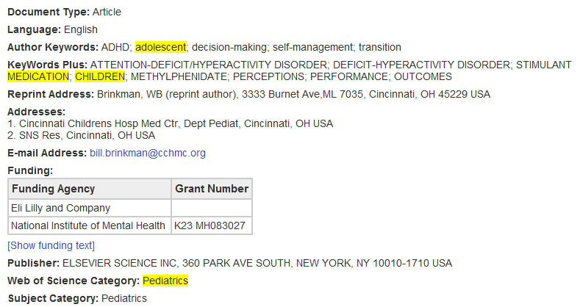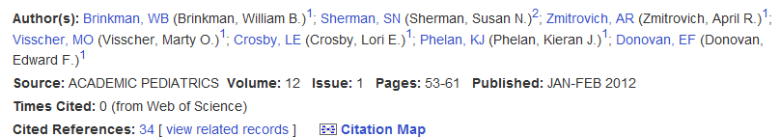This view also links you to citation maps like the following:

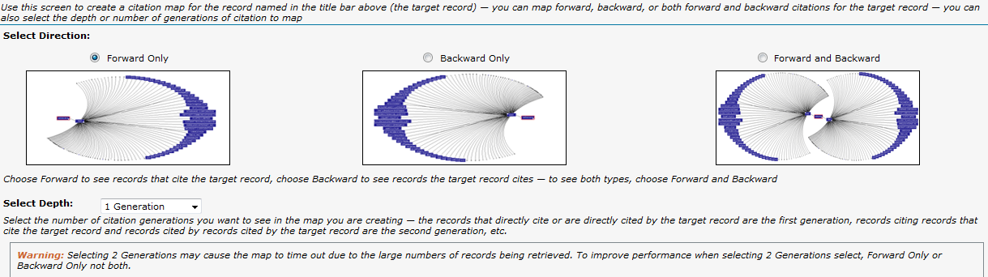

Web of Science is also THE source for finding an author’s H-Index Impact Factor.

Method 1 (MUCH the easiest)

Click the **Author Finder link** at the top of any page

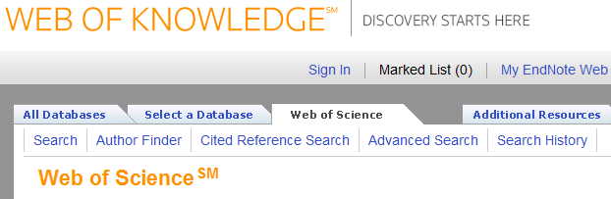Type in the author surname and first initial. You may want to leave middle initial off both this type of search and the previous one to make sure you capture citations in which author neglected middle initial or journal policy is to exclude middle initial even when provided. Click **Search by Name**.

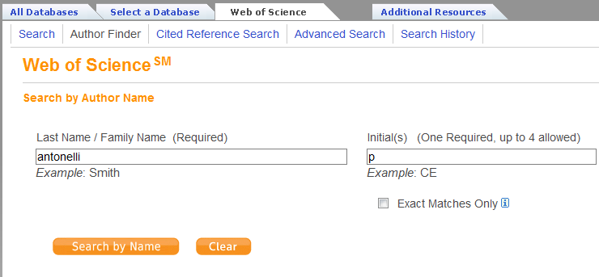On the resulting pages (see below), click checkboxes of likely authors. Since this search will bring up multiple “sets” of author possibilities and only 10 display per page, you may want to use the checkboxes in the left sidebar under Refine Author Sets, using Categories, Institutions and Countries to narrow down the list of possibilities. In our example on the next page, we narrowed from 183 possible author sets to 54 by clicking through the pages.

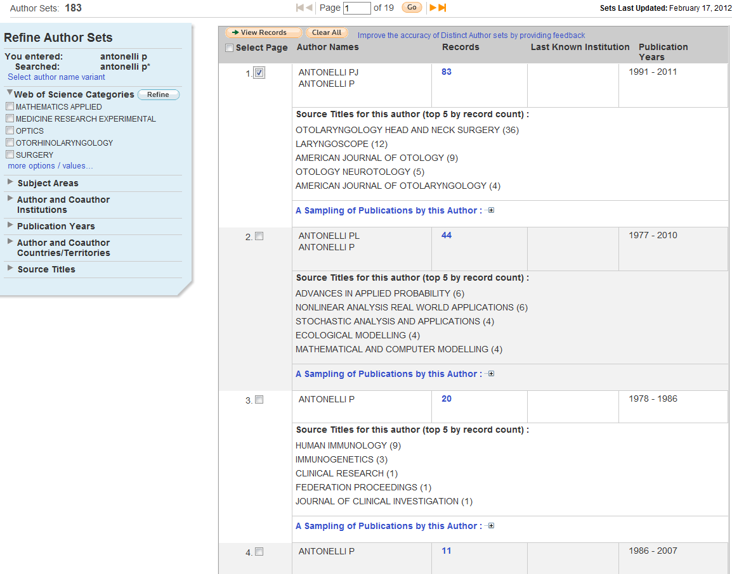

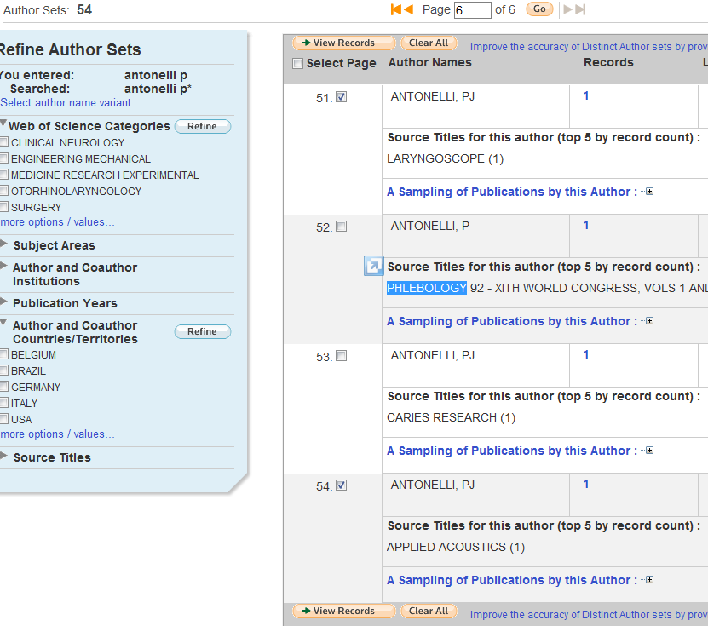Select by clicking checkboxes, using navigational arrows to next page of author sets and finally clicking **View Records**.

Then follow the steps for Method 2 above: Click **Create Citation Reports** and check by changing Sort to **Times Cited** and matching item # with Times Cited #.

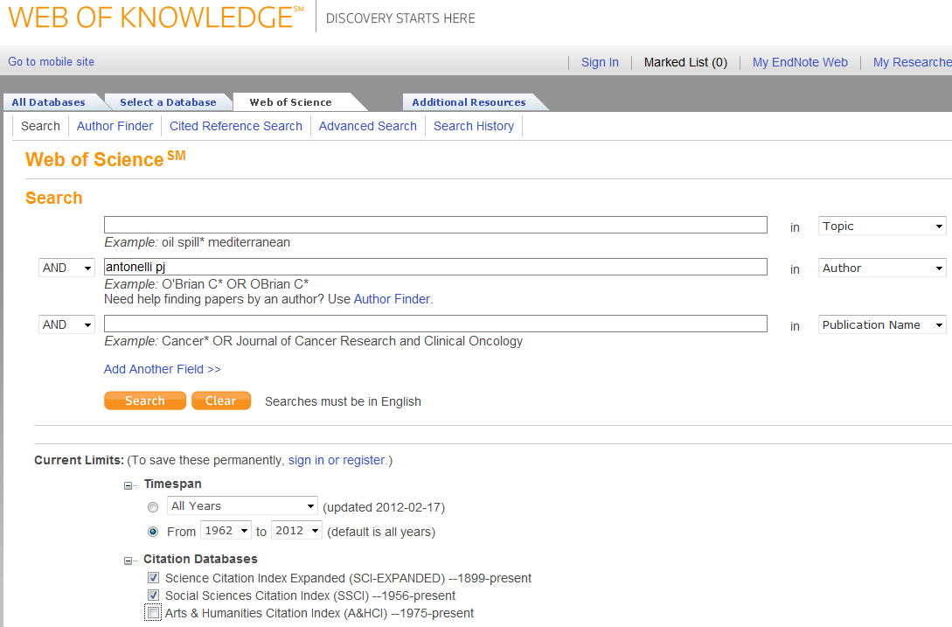**Method 2.** Type author name in **Author** line. Set **Limits** beneath search boxes to your target author’s probable publication year range and the types of research s/he’s most likely done. Click **Search.**

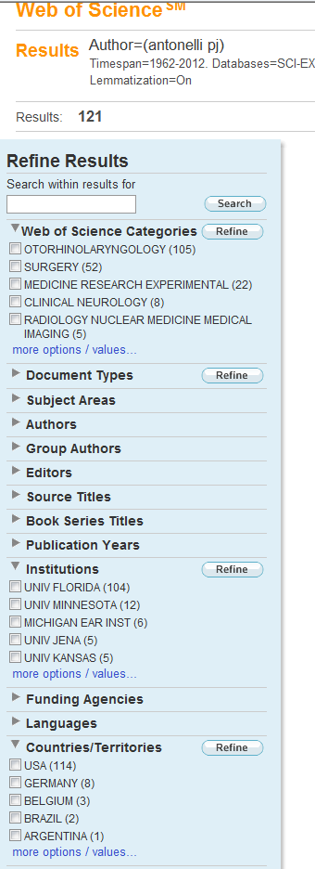In the results page’s left sidebar, click the arrows beside the headings for checkboxes to limit to authors of this name from a given institution (ONLY if the author has always worked out of one institution) or countries/territories (again, only if the author has always worked out of one.)

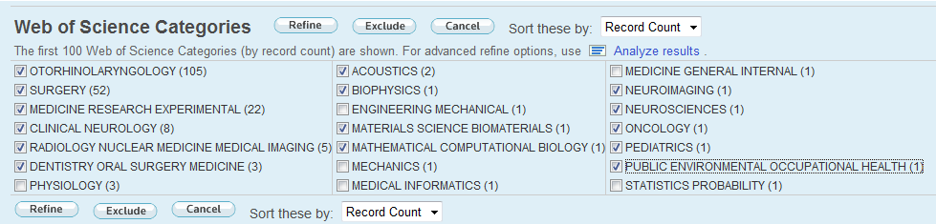Given most authors’ job mobility, it’s probably best to limit by the disciplines (“**Web of Science Categories**”) in which the author works. In the case shown, the author is an Otolaryngologist possibly working in *all* the areas shown, so I want to click the **more options/values** link under the “Categories” checkboxes to make sure I get a complete set of results for this author ( the h-index is dependent on as complete a set of citations as possible .)

Click **Refine** to run the search.

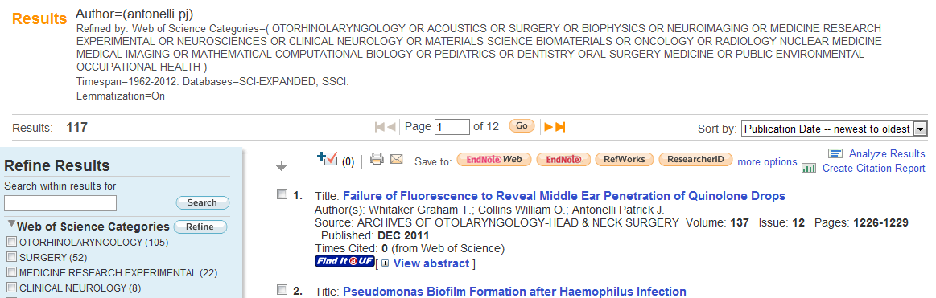Click **Create Citation Reports** upper right just above results.

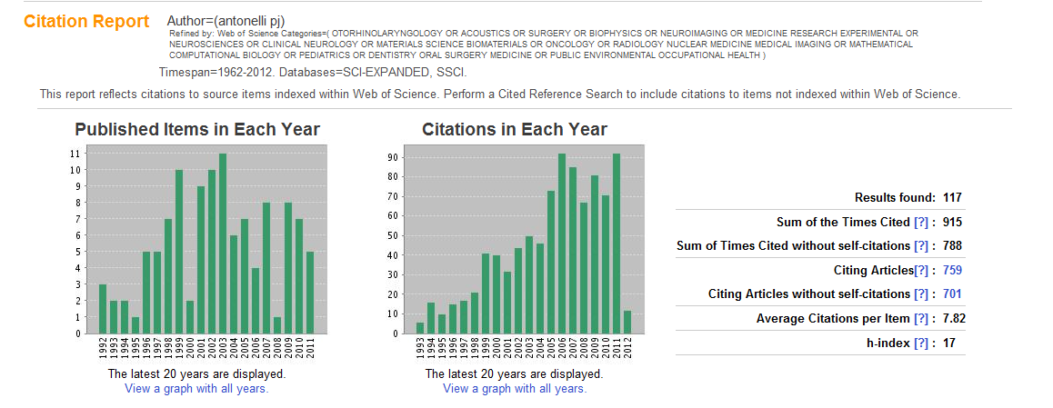h-index for the given author’s citations is the last figure given to the right of the bar graphs.

To check this, return to the Results list, change the Sort pull-down upper right above results list from its Publication Date default to **Times Cited - Highest to Lowest**, then scroll down until the **Times Cited** matches the item number.

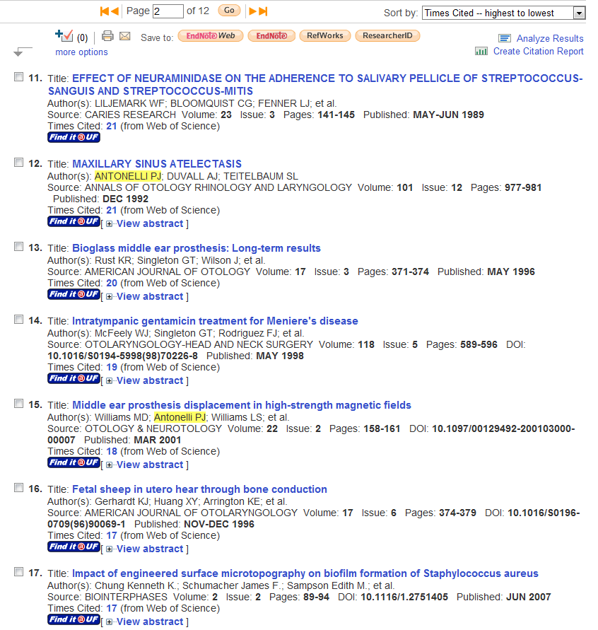

**EndNote-**

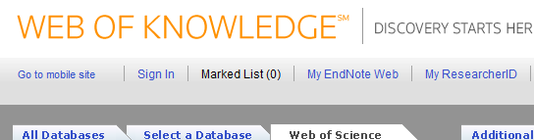Near the top of the resulting page, select **My EndNote Web**

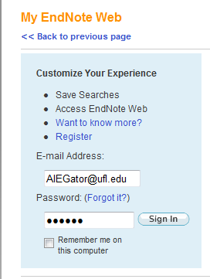

Register for this shareable version of EndNote on campus. You’ll be able to access off campus, but registration should be done on a computer with a UF IP address—ie on campus.

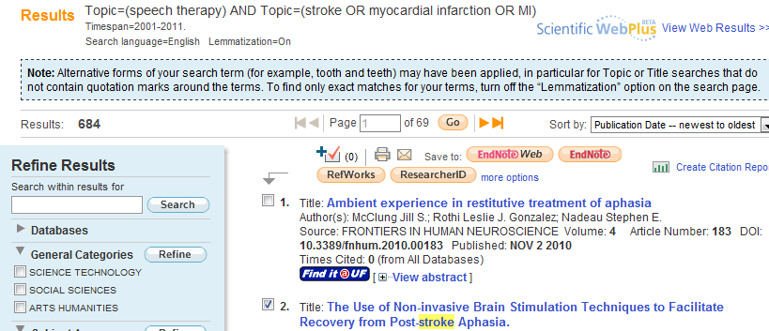Search and select results to send to your EndNote Web library. Click on EndNote Web beside “Save to” above the results.

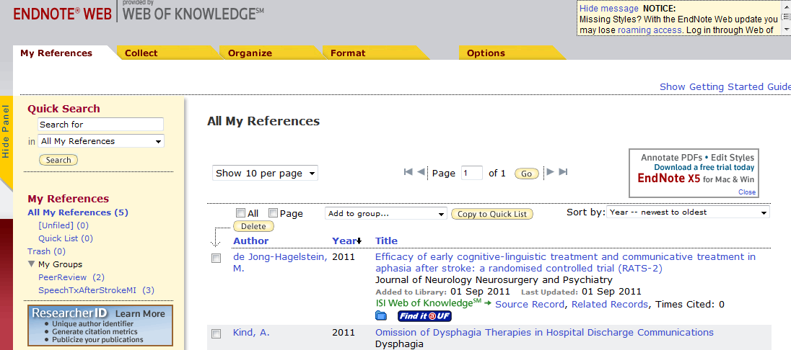“My Groups” (left sidebar near bottom) are folders to store citations in.

Tabs across the top:

**Collect** — Recommend ONLY for getting citation information from KNOWN items from our library catalog or a PubMed or Web of Science into your EndNote Web library to avoid typing it in or saving it and importing it separately. The Search function at Collect is set up so that you either have to know author/title/year to search on or the system will do a very broad search for your terms in the title and abstract of all items in the database/catalog chosen, with the end result it brings WAYYYYY tooo many irrelevant references into your library. Even before this class, you could do a more precise search in the database than the computer-generated search in this Collect—Title/Keyword/Abstract function. Recommend for Do your search in the database and send your selected results to EndNote Web

**Organize** - Rename or share or use shared groups here.

**Format** - Select the bibliographic style for your references here.

**Options** - Change your password or email address or download installers here. Don’t use the Collect tab—it’ll do a broad search and bring WAYYYYY tooo many irrelevant references into your library!

**Menu** For something you knew on our pre-7/1/09 website, click **Menu** for “old” headings & links.