**UF Health Science Center Libraries Resources for Speech, Language, Hearing**

<http://www.library.health.ufl.edu/>

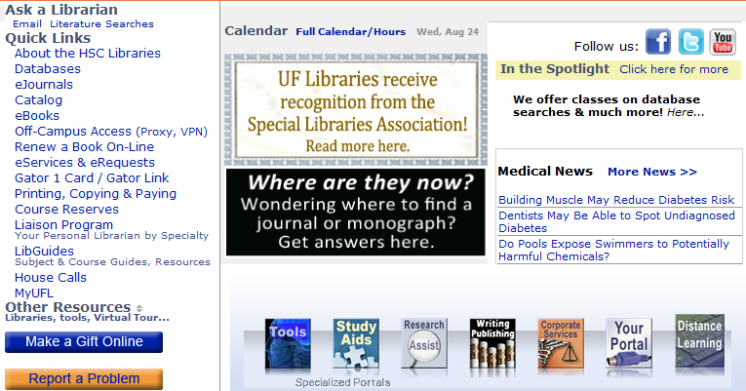From off-campus OR a computer with a non-UF IP address:

**START** with **Off-Campus Access** should be your first step in accessing electronic databases, journals and books.

Click Report a Problem to let us know if you can’t get access to a journal/book/ database online that our catalog/databases page says we have access to.

**VPN** (Virtual Private Network) = software you download that assigns whatever non-shared computer you’re on an IP address within UF’s valid range.

**EZProxy** connects you without downloading software, though you need to login each time and will be popped out without notice if you use your browser’s Back button to navigate rather than links on the page/screen and that means you’ll need to log in again.

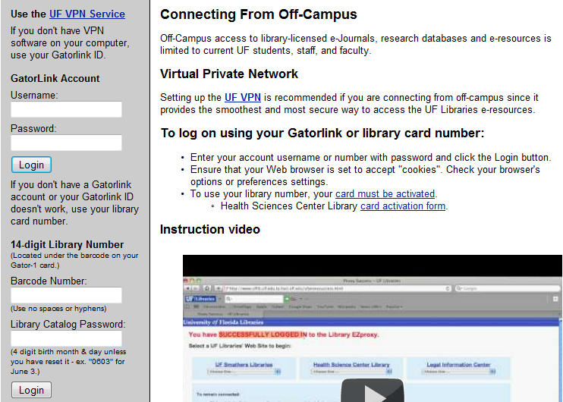

Click **Launch EZ Reconnect** to log

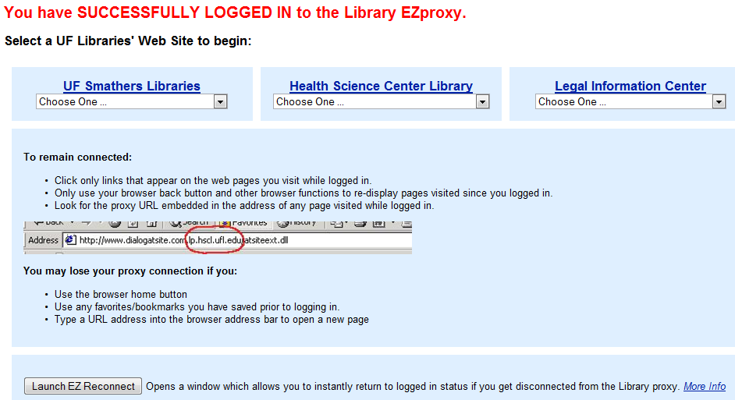

**Basic Searching Review**

**Truncation** *

velopharyn* = retrieves velopharynx, velopharyngeal

**Phrase searching** “ two or words adjacent in order given”

“spasmodic dysphonia” “hearing in noise”

NOTE: Some databases allow truncation within phrase searching; others (PubMed) do not. PubMed’s automatic “term suggestion” feature does NOT put quotation marks around 2+ word suggestions—you’ll have to do this manually if you require the words to be adjacent exactly you type them in.

**BOOLEAN OPERATORS (AND OR NOT)**

AND requires *both terms* to be present in all retrieved items. Generally used with *different concepts*:

speech AND hearing

OR allows *either* term to be present. Generally used with *synonyms*:

speech OR verbalizing

NOT excludes citations with the word after NOT

hearing NOT congressional

**HISTORY** – in **Advanced Search** in most databases. Allows you to

* **view results from previously run searches by clicking hyperlink under Result at right)**
* **combine previously run searches by left mouse-clicking hyperlinked # under Search at left** **and selecting the appropriate connecting word/command)**

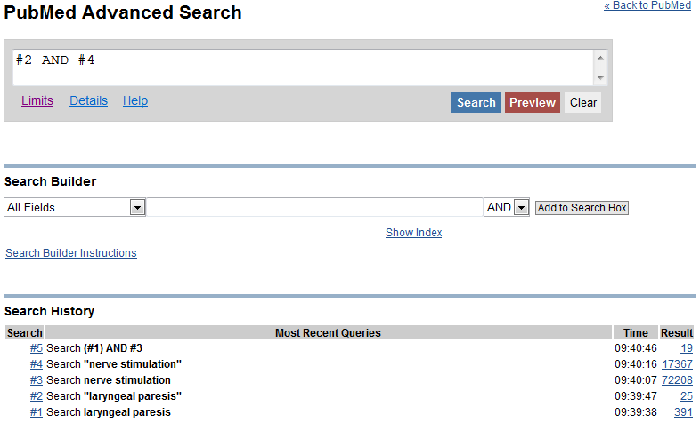



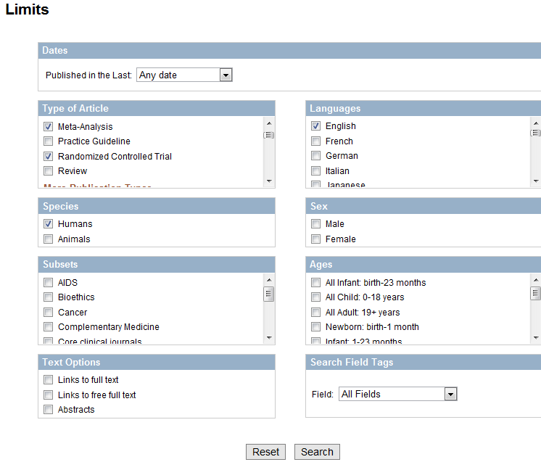**LIMITS** – Use checkboxes and pull-downs to indicate your criteria.



**FIELD searching**

Available in Basic search with field tags ([au], etc. in PubMed) OR in Advanced Search pages in PubMed or Ebsco

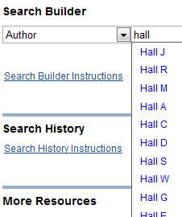

Notes:

1. Authors and publishers vary in the inclusion of initials beyond the first, so an *inclusive* search should probably **only** include **the first initial**.



b) If you get too many irrelevant retrievals with this strategy, add terms about the subjects this person researches or institutions/organizations with which the author has been affiliated.



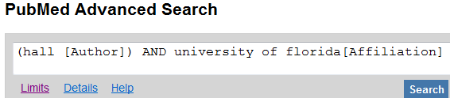

You can also use this to search only in certain journals, on specific subject headings or for specific pharmacologic actions

**Subject headings**

Most databases use standardized terms for common, important concepts. They hire experts to read and summarize the content of articles in these words/phrases. If we use these subject headings, we can tap into the experts’ summaries of the article’s main content and also their pulling together of all synonyms and word variations. For example, instead of searching for keywords (all the words any author might have used to describe children from birth to adulthood and all the various forms of all those words [adjective, noun, adverb, plural, singular, possessive] and their various spellings [pAediatric] found anywhere text including after excluding words lie BUT, EXCEPT or briefly mentioned in the abstract or text but providing little info on the topic, we should be able to get a higher percentage of relevant citations using a subject heading like “pediatric patients”: the experts have already summarized the content for us, determined the concept to be important enough in the article to warrant getting its heading attached to the citation, and pulled together of all synonyms and word variations.

Many databases use their own headings rather than 1 universal set of headings. And they refer to the headings/storage place of the headings by different names such as Thesaurus, Headings, Descriptors. This means that when you move between databases, you need to be aware of these differences.

PubMed’s subject headings are called **Me**dical **S**ubject **H**eadings, commonly shortened to **MeSH**.

If a keyword term is also a subject term, PubMed automatically includes the subject heading in the search. Here are the strategies PubMed used for searches on thyroidecomy:

"thyroidectomy"[MeSH Terms] OR "thyroidectomy"[All Fields]

and its strategies for *voice quality*:

("voice"[MeSH Terms] OR "voice"[All Fields]) AND quality'[All Fields]

More reasons to use subject headings:

1. You get a **definitions** of exactly what MEANING (definition) the system is searching on, so you can be sure it’s searching for what you intend to search for.
2. **Subheadings**

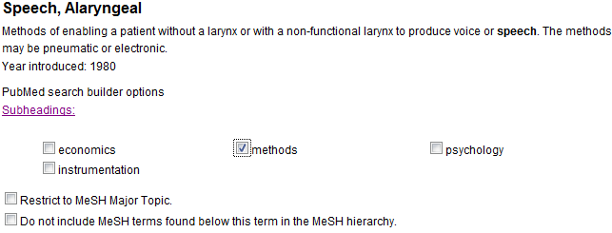PubMed and some EbscoHost databases (including CINAHL) allow you to search on one or more specific aspects of a topic as shown below on a search of:

1. **MAJOR** When the experts have read an article and chosen the subject headings to summarize its contents, they also specify which ideas are the central or major foci of the article.

Scanning the list of subject headings can more quickly assess the value of an article than reading a narrative abstract.

It’s the only way to evaluate the usefulness of the relatively few citations without abstracts in PubMed.

At right is the list of subject headings (MeSH) terms and *Major* Topics (MAJR - marked with an *) for one article in PubMed.

Possible subject heading search strategies:

"Speech, Alaryngeal"[**MeSH**]

"Speech, Alaryngeal"[**Majr**]

A [**MeSH**] search **will** include [**Majr**] results.

A [**Majr**] search **will NOT** include [**MeSH**] results.

A [Majr] search will NOT include [MeSH] results.

Most databases display subject headings arranged hierarchically, from broadest/most general to narrowest/most specific. These “trees” of terms shows you appropriate terms for more general concepts related to your term or more specific ones so that you can adjust your search accordingly.

For example, if you got no results searching on ***Rehabilitation of Speech and Language***, you could try the next broader-level terms (***Rehabilitation***) or one of the even more general terms (***Therapeutics*** OR even broader, ***Analytical, Diagnostic and Therapeutic Techniques and Equipment***).

If searching gave too many results, you could move DOWN the “tree” of terms to a more specific term, for example to ***Myofunctional Therapy*** or ***Voice Training***:

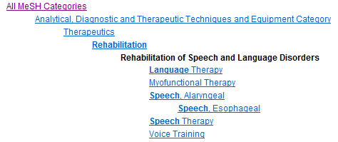

Original term

**More** Specific

**More General**

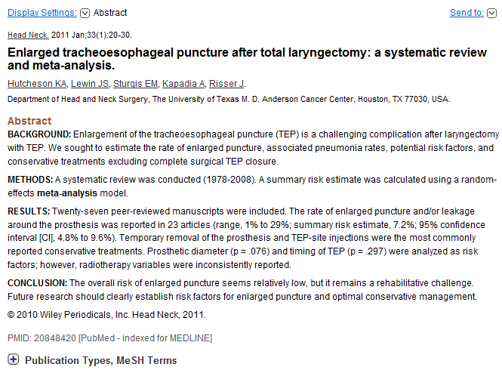Where to find MeSH headings

1. Click the title of an individual article. Or click in the upper left of a set of results from a keyword search, then set **Display Settings** to **Abstract** and identify a relevant article.

Click on the **+** in front of its **MeSH Terms** of the revelant article.The terms are hyperlinked so you can run a search on the same term/subheading Major/MeSH as in the original. For example  will search on Alaryngeal speech methods as a major focus of every citation retrieved. It will NOT retrieve citations where the topic is mentioned (MeSH) but was not considered a major focus of the article by the expert who read the article.

1. If you know the term, you can type it in PubMed’s search box on any page and set the pull-down menu to **MeSH**
2. Click on **MeSH Database** from PubMed’s homepage, then type in your term.

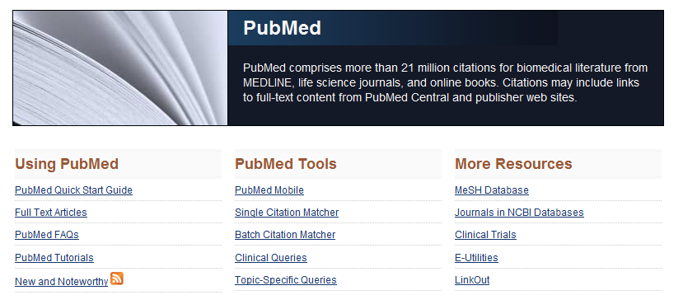

If you are given a list of terms, the most general will be at the top. Read through all the terms to make sure a more specific one isn’t available. Click on the term to reach this page if you want to limit to specific aspects (subheadings), require the concept to be a major focus of citations retrieved or if you do NOT want PubMed to return articles on more specific headings (which will be shown at the bottom of the page—in this case Esophageal Speech is the only more specific term that would be searched along with Alaryngeal Speech.)

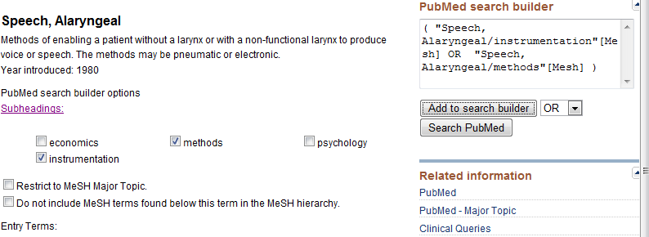Click **Add to search builder** in the right sidebar to put the item in the box. If you search 2+ subheadings, as we did below, change the default AND to OR. Click **Search PubMed** to run the search.

To apply filters for evidence-based literature, click **Clinical Queries** in the right sidebar. ONLY the subject heading will be transferred to the subsequent page. If you want subheadings in this search for evidence-based literature, you’ll have to type them in (as shown with a keyword below).

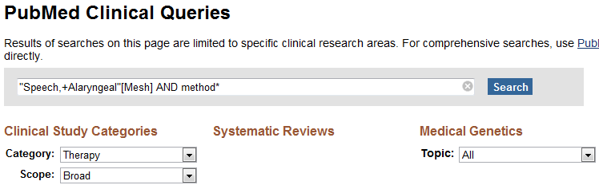 **Evidence-Based Practice** (in PubMed) (see previous paragraph on how to get there from the MeSH page





Select category and breadth of scope (narrow or broad) for Clinical Studies or specific topics from Medical Genetics pull-down.

You can also go directly to Clinical Queries from PubMed’s main page, center column labeled **PubMed Tools**.

**Navigating Back to the Home Page:** From the Advanced search’s upper right corner

From the bottom of any page:

**Saving Specific Citations**

Select results to store for later use. Databases use different names for this storage space. PubMed uses the term Clipboard.

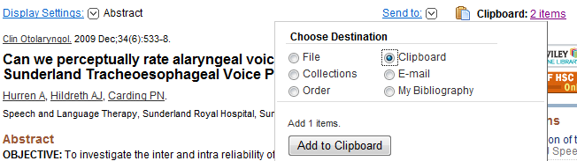

Click **Send to** just to the right of center, then click the **Clipboard** radio button, then **Add to Clipboard** button.

Upper right shows 2 items have already been added to the Clipboard.

Other useful databases’ storage spaces have these names:

**Ebsco** databases = **Folder**

**CSA** = **Marked Records**

**WilsonWeb** = **Get Marked**

**Saving Search Strategies & Setting up Alerts**

Click **Save Search** (below search box in PubMed).

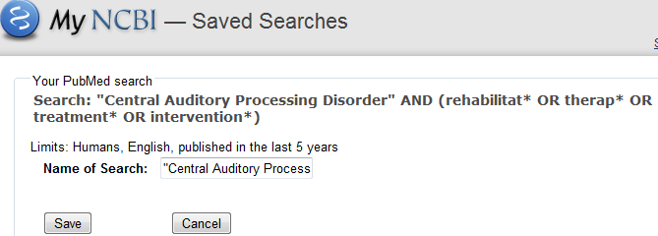In all databases, you need to register for this free storage and email service.

Default file name is usually your entire search string, so may want to rename the search.

Click **Save.**

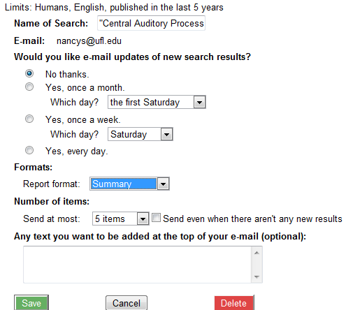Fill out the form if you want PubMed to email citations on your search as they enter the database.

PUBMED ONLY

MyNCBI will store your saved search strategies and results and show you what new items have come in on your terms even if you haven’t requested email alerts. It will store citations in separate collections as well as collections of citations. You can also set up additional filters for all results

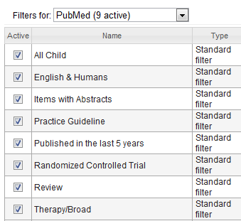



Collections →

Saved Searches ↓

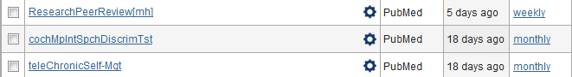

An email alert from a PubMed search will probably look like this:

**ACCESS ICONS**

 Most databases use this icon. Select PDF rather than HTML option to get print-like copy of article so you can reference exact page numbers needed for citation of quotes, ideas, statistics.

PubMed icons – Green Free button gets full-text from any computer without login/VPN. Orange buttons only get as much full-text as UF has licensed IF you’re using a UF-IP’d computer, VPN or the Proxy AND accessed PubMed thru UF Libraries’ databases pages.

**Evidence Based& Cochrane** link – slightly different between the included databases. **Database of Systematic Reviews** = THE ONLY source of full-text of these documents, even if you’ve identified the review in PubMed or some other database. Full text is available thru this link:

Central Register of Clinical Trials full text may be available thru  tho many of these are in journals and can only be accessed thru the library catalog or ejournals page or in print on library shelves.

**DATABASES** – Many relevant ones complement PubMed!

|  |
| --- |
| Individual Databases |
| **ABI/INFORM -** business periodicals, industry news and analysis, and information on local markets |
| **Dissertations and Theses –** Identifies, provides abstracts and many available in full-text. (Price to buy~$40.) |
| **Evidence-Based Medicine/Cochrane Reviews** –Scientifically rigorous systematic reviews. |
| **FirstSearch** – Databases of mostly “unpublished” documents:  **ArticlesFirst** – articles, letters 1990->  **PapersFirst** - every published congress, symposium, conference, exposition, workshop, meeting received by British Library since 1993. Some may have been published, possibly under a different title.  **Proceedings** as above, but organized by conference/workshop rather than by individual paper within. From 1993.  **WorldCat Dissertations** –8K+ dissertations & theses from around the world. May want to limit to English. |
| **IEEE Xplore -** technical literature in electrical engineering, computer science, and electronics |
| **JCR Web –** (Journal Citation Reports) 2 editions: *Social Sci,* *Science* –may need to check both. Reports stats on % of articles from a journal cited in the year published, % of older articles cited, etc. Used to evaluate journal importance/quality. Check individual journal t itles or rank journals as a group on a subject. |
| **Lexis-Nexis Academic -** *Legal* (intl, federal & state codes and court cases, patents) |
| **PubMed** – biomedical, health admin, policy journal articles. |
| **StatRef –** searches electronic classic medical textbooks simultaneously; displays sections of texts containing (highlighted) search terms. Good place to start on a topic you don’t know well. *Resources* tab contains:   * *Stedman’s Medical Dictionary (28th ed, 2006, tho)* * Link to *National Guidelines Clearinghouse* * *Anatomy TV’s Dentistry* with relevant diagrams and animations of head and neck. |
| **UpToDate –** synthesized summaries of clinical info. Available only on campus. |
| **Web of Science –**Science, Social Science, Arts & Humanities editions. Find articles that were used to build an article and subsequent articles that cite that article, thereby tracing the “evolution” of a idea/theory/practice. Great tool for expanding a bibliography from even a single citation. |

|  |
| --- |
| **Federated Search Sources**  *Multiple databases on one platform - search simultaneously by keywords (tho not by subject heading)* |
| **CSA** (Cambridge Scientific Abstracts) – higher percentage of physical sciences |
| **ASSIA** (Applied Social Science Index & Abstracts) – social svcs, psych, sociology, health info  **Biological Sciences** (heading) includes following databases:  **Biotechnology Research Abstracts** – for assistive devices  **CSA Neurosciences Abstracts**  **Genetics Abstracts** and **Human Genome Abstracts** - 2 databases for genetic etiology  **Health & Safety Science Abstracts** - for occupational hearing loss  **Conference Papers Index** – major int’l conferences (incl.biotech & clin medicine) from 1982  **Electronics and Communications Abstracts** – for assistive devices  **ERIC** (Educational Resources Information Center)  **Linguistics and Language Behavior Abstracts** –communication strategies, speech/ language acquisition  **NTIS** –1964 forward primarily US (but also Canada, Soviet, European) govt-funded research  **PAIS International** and (probably less useful) **Worldwide Political Science Abstracts** - policy  **Social Services** and **Sociological Abstracts** |
| **Ebsco**  - higher percentage of social sciences than other databases. USE WITH FIREFOX or nonIE Browser! |
| **Academic Search Alumni & Premirer –** many disciplines, mostly full-text, not all scholarly sources  **Ageline** – aging issues  **Business Source Premier** and **Health Business** (2 DBs on management issues, the latter specifically health-related)  **CINAHL** - Cumulative Index of Nursing and ALLIED HEALTH Literature  **Communication & Mass Media Complete –** Lots onTV, radio, etc. but also simple verbal/written message transmission  **Professional Development Collection** -For education professionals (teachers, principals, etc.)  [**Psychology and Behavioral Sciences Collection**](javascript:__doPostBack('ctl00$ctl00$MainContentArea$MainContentArea$SelectDbControl$dbList$ctl24$ctl00$titleLink','')) – mostly included in PsycINFO  **PsycINFO** – psychology and psychosocial aspects of physical conditions  **Sociological Collection** - social behavior, com’ty development from 500+ full-text mostly peer-reviewed journals  **SPORTS Discus –** exercise, fitness, nutrition |
| **Lexis-Nexis Academic Universe –** media & legal |
| **Business –** may be too profit-oriented/commercial to readily apply to healthcare  **Legal** - int’l, federal & state codes and court cases, patents  **News** *-* newspaper, TV/radio broadcast transcripts from around the world, both trade and popular |
| **WilsonWeb** – business, legal in addition to hard & soft sciences |
| **Applied Science & Technology** - 1 database including acoustics, communication &info tech from1983  **Biological & Ag Index** - 1 database including biotech & genetics  **Education** & **ERIC** – 3 databases, each covering education  **General Science**  **Legal Periodicals**  **Social Science** |

**Database vs. Catalog**

These *databases* list what has been *published*.

The library’s *catalog* lists what the library has *purchased or licensed* for UF users.

The two types of tools are linked so you can search a database to find what’s been published (database) and use its link to the catalog to see if UF libraries have access.

BUT! If links from a database to a journal don’t work, check the library catalog and/or Ejournals page to make sure you don’t have access before ordering it from another library or giving up on the article.

**Catalog**

From the library’s homepage [www.library.health.ufl.edu](http://www.library.health.ufl.edu) under **Quick Links** in left sidebar, click **Catalog**.

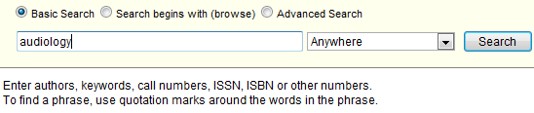

Use the pull-down to specify where your terms should appear – in the title (of books or any format), title of journals only, author name, etc. Click **Search** to run the search.

Total # of results at top left. 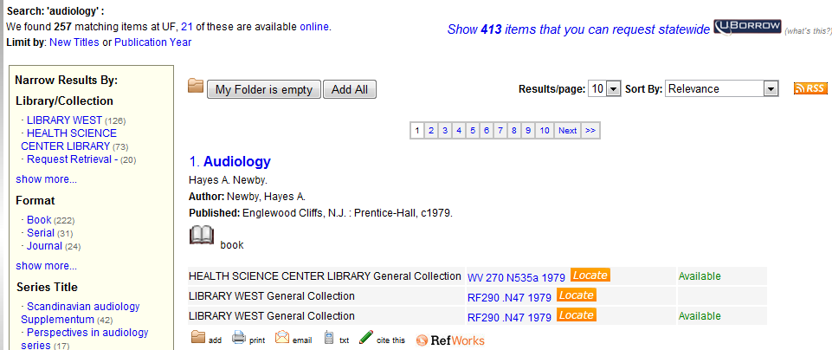

Click a link on the ***left*** to **add a term to your search**. The number in parentheses is the # of results you’ll get. For example, clicking on Book above would bring 229 results, clicking on Journal would bring 21.

Use the buttons in the ***center*** to add a result to a storage space (**My Folder**—see above the results list) for later print-out or email, to email or text-message a citation to yourself, or export it to RefWorks, a database that creates bibliographies for you. To remove unwanted items from **My Folder**, click its checkbox, then **Remove** button. The catalog includes items at our branch library in Jax!

Use the pull-down in the upper *right* to **re-order the results by a different criterion** (default is relevance.)

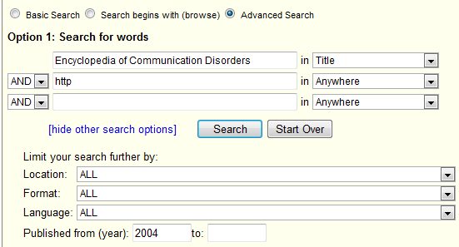

**Advanced Search**

Use this when you know-- before you click the Search button--how you want the search limited—by location, specific author & title, etc.

Type **http** in a search box to limit to electronic books.

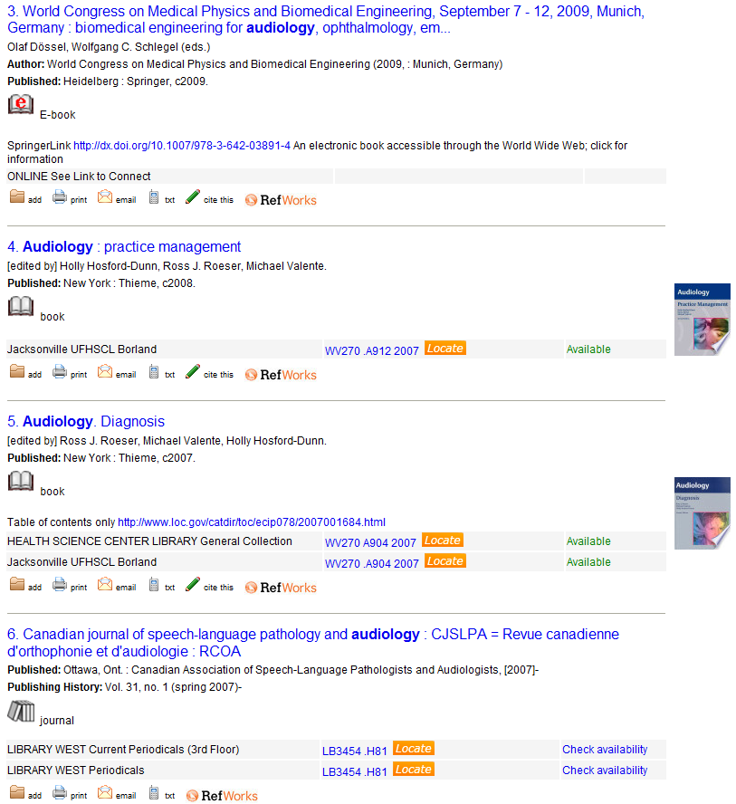The 1st item is a full-text **electronic** book.

The **print** books have call # (WV270…2007). This book is only in our Jacksonville library.

This link only provides the **table of contents** electronically.

This title is a print journal. Click **Check availability** at right to see which paper volumes (years) are held on the shelves.

**Electronic Books** – 3 methods of accessing, all needing connection via a UF-IPd computer, VPN or proxy.

1. If you **know which company/product controls a book**, you can check the Ebooks link on the library’s homepage.
2. Use the library catalog



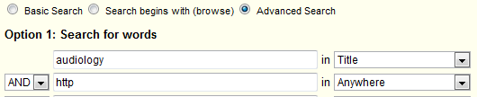

1. 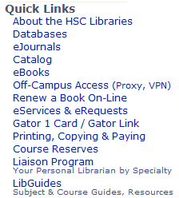Use the links in my LibGuide for **Public Health/Health Professions**, then for **Audiology**, then **Books** tab.

**Bibliographic Software**

Once you’ve found your items, you can use a bibliographic software package to create in-text citations and bibliographies/reference lists.

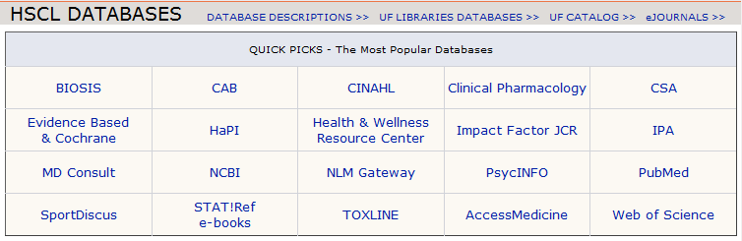**EndNote-** purchase is your responsibility but l and my HSC librarian colleagues will make “house-calls” (consult with you in your office) to show you how to use the software. Version X5 (aka 15) released several weeks ago. Versions of EndNote lower than X4 have had issues with versions of Word below 2010 and Internet Explorer below 7.

**EndNote Web** from the library’s Databases page, select **Web of Science**

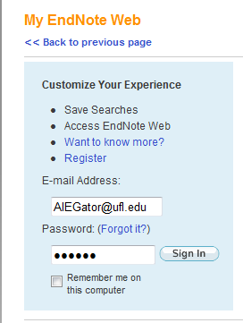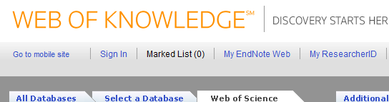Near the top of the resulting page, select **My EndNote Web**

Register on campus. You’ll be able to access off campus, but registration should be done on a computer with a UF IP address—ie on campus.

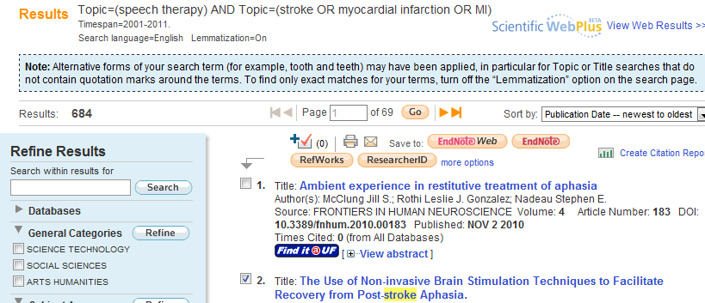Search and select results to send to your EndNote Web library. Click on EndNote Web beside “Save to” above the results.

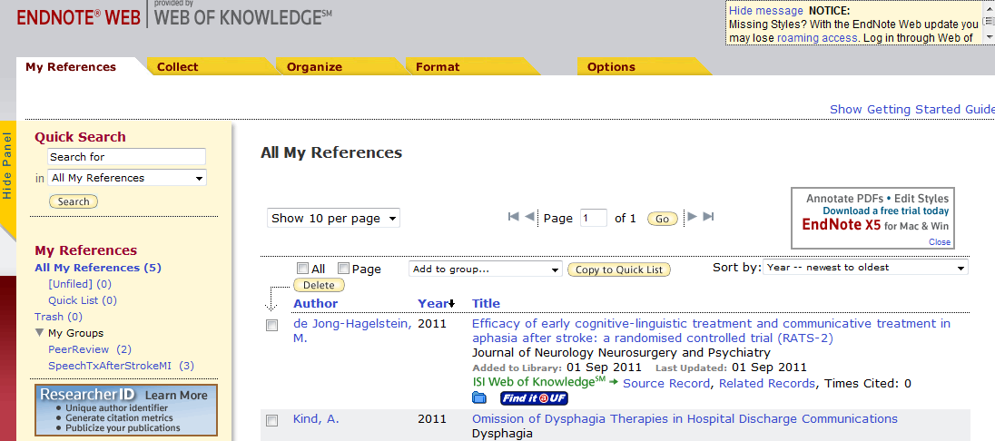“My Groups” (left sidebar near bottom) are folders to store citations in.

Tabs across the top:

**Collect** — Recommend ONLY for getting citation information from KNOWN items from our library catalog or a PubMed or Web of Science into your EndNote Web library to avoid typing it in or saving it and importing it separately. The Search function at Collect is set up so that you either have to know author/title/year to search on or the system will do a very broad search for your terms in the title and abstract of all items in the database/catalog chosen, with the end result it brings WAYYYYY tooo many irrelevant references into your library. Even before this class, you could do a more precise search in the database than the computer-generated search in this Collect—Title/Keyword/Abstract function. Recommend for Do your search in the database and send your selected results to EndNote Web

**Organize** - Rename or share or use shared groups here.

**Format** - Select the bibliographic style for your references here.

**Options** - Change your password or email address or download installers here. Don’t use the Collect tab—it’ll do a broad search and bring WAYYYYY tooo many irrelevant references into your library!

**Menu** For something you knew on our pre-7/1/09 website, click **Menu** for “old” headings & links.



These “mini-portals” link to tools and sites of possible use to you.

3 of the mini-portals may help: **Tools** links to various tech gadgets, **Study Aids** to images for anatomy study and **Research Assist** to grant sources, health statistics , ways to ID experts in a field, etc. Look for a writing/pub-lishing mini-portal later this fall.

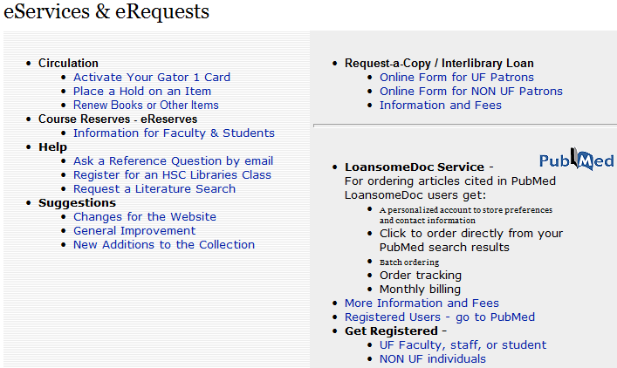Click **eServices and eRequests** to renew books, place a hold on something checked out that you want next, ask a question of a librarian, take a class on using a database or doing systematic reviews, or request a copy of something not held in UF libraries.

Note: You can get materials from other libraries (Interlibrary Loan) free of charge. Turnaround time from request receipt to delivery varies from 24 hrs to 10 days.

**Other resources:**

**TRIP** (Turning Research Into Practice) database <http://www.tripdatabase.com/>. Citatons pulled from PubMed, Cochrane and other databases for evidence-based synopses, systematic reviews, practice guidelines, core primary research, e-textbooks, patient information. Pulls images and categorizes PubMed results into subtopic categories: etiology, dx, tx, prognosis,etc but not linked to full-text at UF.

**Quertle** – <http://www.quertle.info/v2/> searches PubMed and BioMed Central (latter contains online journals not necessarily indexed in PubMed) Not linked to full-text at UF

**Campbell Collaboration** – <http://www.campbellcollaboration.org/library.php> “Library” of evidence-based social science publications. Use Browse feature in the left sidebar to navigate.

**CODI** (Cornucopia of Disability Information) <http://codi.buffalo.edu/> Not linked to full-text at UF

**Ask Dr. Wiki** [http://www.askdrwiki.com/](http://www.askdrwiki.com/mediawiki/index.php?title=Physician_Medical_Wiki) (“nonprofit 501(c)(3) educational web site made by physicians for physicians, medical students, and healthcare providers” per About Dr. Wiki at <http://askdrwiki.com/mediawiki/index.php?title=Who_is_Dr._Wiki%3F> )

**Ganfyd** <http://www.ganfyd.org/> . Requires medical license for posting so somewhat filtered/monitored for quality/accuracy/current-ness.

**Merck Manual for Health Care Professionals** ebook – Ear, Nose and Throat Disorders section <http://www.merckmanuals.com/professional/sec08.html> Content last modified 10/09, last full review/revision 2/10 so a bit dated

Questions? I’m here to help: 352.273.8417 [nancys@ufl.edu](mailto:nancys@ufl.edu) Ask for me at the Information Desk by the Health Science Center Library’s 1st floor door). I can’t do your searching for assignments but I can advise you on sources and terms to use and help set up alerts.